Question 13

Extended access-list will be in the range of 100-199 and 2000-2699. It filters traffic based only on the source IP address

Make the below given network

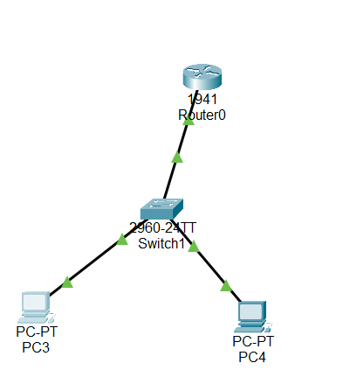

Now configure swith and create vlan’s

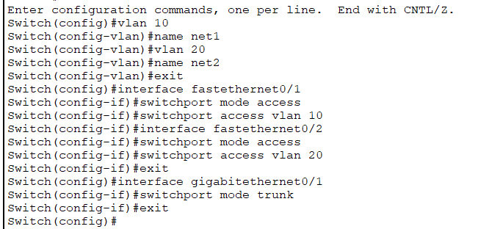

Now configure the router to communicate between inter vlan

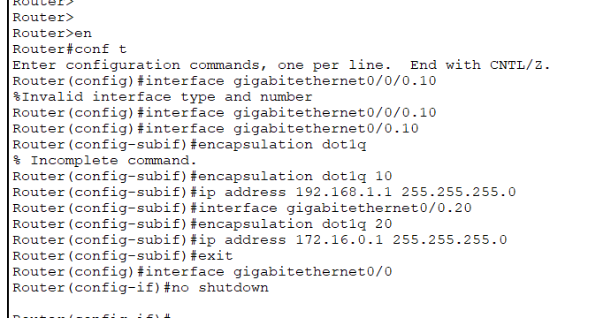

Now if you try to ping another network it works.

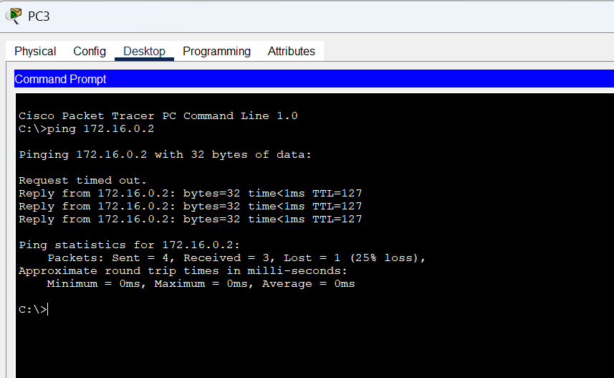

Now we are going to deny only the icmp packet from 192.168.1.2 using extended access-list

It is the great advantage of extended access list. We can give access to ip’s, protocol, ports

Configure the router with below command

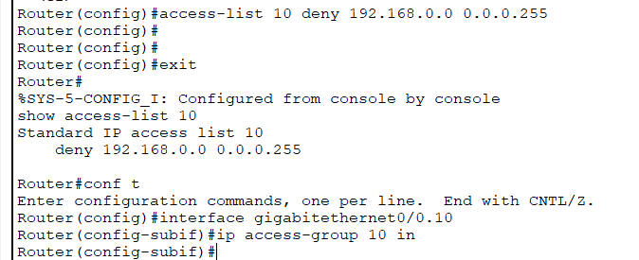

Now you can see the ping is unsuccessful

